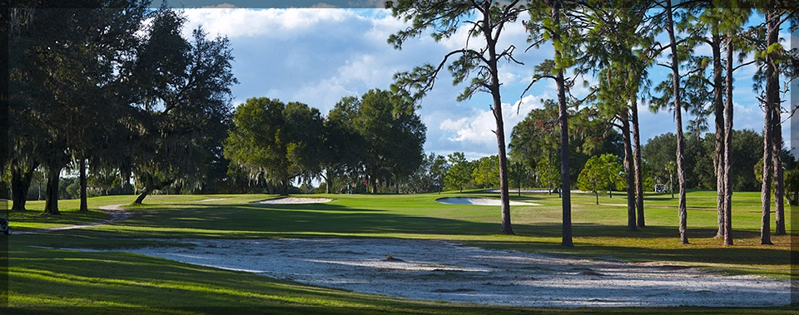

- 69TH ANNUAL TOURNAMENT…BE PART OF HISTORY on a vintage Donald Ross course!
Earn GolfWeek/W.A.G.R. points!

- THREE ROUNDS OF MEDAL PLAY; CHAMPIONSHIP FLIGHT WILL BE CUT TO TOP 70 AFTER 36 HOLES.
.

- $325 ENTRY FEE INCLUDES: THREE ROUNDS OF MEDAL PLAY.

- LUNCH PROVIDED EACH DAY. COCKTAIL/PAIRING PARTY SATURDAY NIGHT.

THURSDAY, MARCH 19TH 2026. FRIDAY, MARCH 20TH SATURDAY 21st SUNDAY 22nd

Practice Round, First Round Second Round Final Round
$39 AM, $34 PM

Call for tee times.
Tourney Players can
Book in advance.

---------------------------------------------------------------------------------------------------------------------------------------------------------------
Name:__________________________________________ Phone:_________________________________________

Adress:_________________________________________ Email:_________________________________________

City:______________________________State:_________ Hometown:____________________________________

March Slope Handicap Index_________________________ Club____________________Telephone______________

Mail entry and $325 check payable to: PMGA
(Fee is $335 if payable by credit card) Azalea Tournament
1715 Moseley Avenue
Name:_______________________Zip:_________ Palatka, FL 32177
CC#_____________________CVV_____________
Exp:_____________________________________

Questions can be addressed to aheartz@pga.com, (386) 329-0141 shop
PMGA will deduct a $50.00 fee for all cancellations. Cancellations will not be accepted after February 15. The PMGA
Reserves the right to reject any entry and adjust handicaps if necessary. Players 18 years of age and under must have a
Verifiable handicap of 3 or less.


Championship Flight
69th Florida Azalea Amateur

